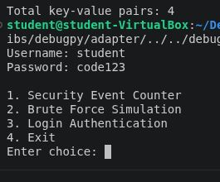

Here you can see that username and password are working

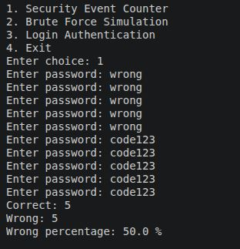
Option 1 security counter, here you can see i got password incorrect 5 times and the password correct 5. in total 10 attempts meaning the percentage at 50%

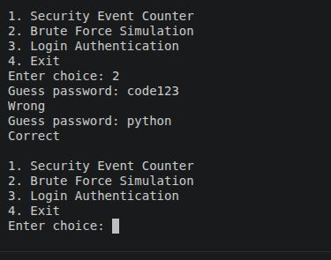

Option 2 brute force, here you can see i entered the wrong password meaning the login was unsuccessful but when i put the right password in it worked.

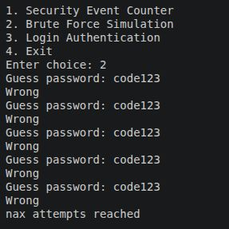
Option 2, here you can see i tried to brute force my way into the system but i got the password wrong meaning i reached my max attempts.

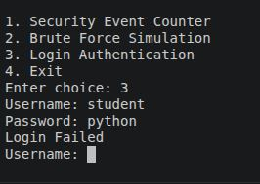

Option 3. this is for the login authentication. You can see that i got the password wrong meaning the login has failed.

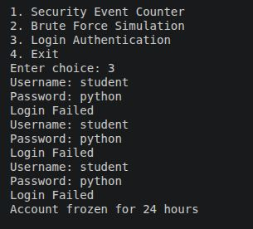

Option 3, here you can see i attempted to enter but got the information wrong meaning that the account has been frozen for 24 hours.

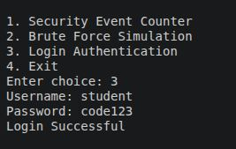
Option 3, here you can see that i got the information correct meaning the login was successful.

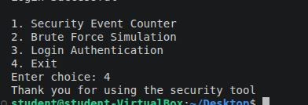

Option 4, once you type 4 it will say thanks for using the security tool

